Purifying two SNARE proteins: Nyv1 and Vam3

department of molecular biology, princeton university

Conor Wilson

2019

**Background**

The fusion of plasma membranes is indispensable to the inner life of the eukaryotic cell; it is the mechanism by which cargo, transported from the site of synthesis inside vesicles, is delivered to its destination compartment1. This fusion process is not trivial, and depends on the action of proteinaceous ‘membrane-bridges’, known as SNAREs (*soluble* N*-ethylmaleimide-sensitive factor attachment protein receptors*), to facilitate docking, tethering, and ultimately fusion1. Although the SNARE subfamily is large, containing a variety of proteins with differing distributions and applications, the fundamental mechanism is highly conserved across all eukaryotes2.

The elegant process by which SNAREs induce membrane fusion is depicted in **Figure 1**. The R-SNARE, which is associated with the surface of the cargo-containing vesicle, binds to Qa-, Qb- and Qc-SNAREs on the surface of the target membrane, forming a coiled-coil complex consisting of four alpha-helices3. However, the initial binding step does not occur through uniform interactions across the entire lengths of each protein; rather, it is driven by their SNARE motifs, domains of the protein which associate and assemble into the SNARE core complex3. These motifs have no defined structure in individual, free SNARE proteins; it is only through close interaction that they form strong intermolecular bonds and adopt a rigid conformation3.

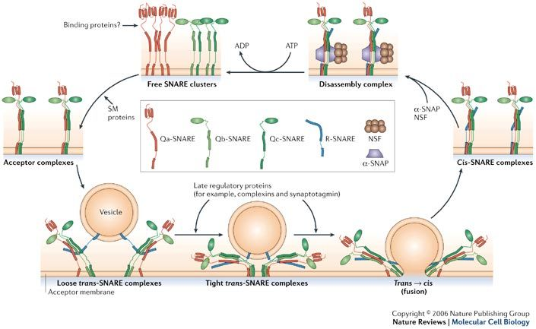

**Figure 1:** Free SNARE clusters on the target membrane, consisting of unassociated Qa, Qb, and Qc SNAREs, are assembled into acceptor complexes with the help of accessory proteins such as the Sec1/Munc18-like (SM) proteins. These acceptor complexes bind to one R-SNARE on the surface of the cargo-containing vesicle, forming a trans-SNARE complex which, upon driving water molecules out of the intermembrane space, generates the force for fusion. A series of steps are required for complex disassembly so that the SNAREs can be recycled for another round of fusion. *(Figure courtesy of Jahn and Scheller, 2006)*

Early research into SNARE protein function quickly identified the basis of these strong intermolecular forces: electrostatic attraction4. At the center of the SNARE core complex lie four charged amino acid residues, in contrast to their largely hydrophobic neighbors. This unusual region of electrostatic charge has come to be known as the ‘zero layer’, and consists of one arginine (R) residue donated by the vesicular SNARE, and three glutamine (Q) residues donated by each of the three target membrane SNARE motifs—hence their names4.

While the fundamentals of the SNARE assembly process are well-known, the model remains incomplete; latterly, research has indicated that not only do SNARE proteins isolated *in vitro* assemble into a complex inefficiently, but they disassemble at a rate which is ‘undetectably slow’1. This is perhaps unsurprising—a theoretical SNARE bundle which could form and separate with little prompting could potentially wreak havoc on intracellular membrane fusion. Thus began the search for other proteins which regulated the assembly/disassembly processes *in vivo*1.

A candidate has been identified in the Sec1/Munc18-like proteins, which are thought to facilitate SNARE complex assembly by recruiting the Qa-SNARE, exposing its motif, and chaperoning it to the R-SNARE, forming a partially-zippered template for the subsequent binding of the Qb- and Qc-SNAREs1. In the organism *S. cerevisiae,* Nyv1, Vam3 and Vps33—yeast vacuole fusion proteins—act as the R-SNARE, Qa-SNARE, and SM protein, respectively5. They have proven valuable model proteins for the fusion process, accounting for the roles of both SNAREs and SM proteins5. Since most research has hitherto focused on the SNARE proteins involved in mammalian neuronal membrane fusion6,7, the use of yeast proteins provides evidence for the conservation of the fundamental model across vastly different species.

Researchers have yet to crystallize Nyv1, Vam3 and Vps33 in complex with one another, although the former two have been independently crystallized with the latter5. A promising avenue for study of the SM protein—SNARE relationship involves binding assays, using such techniques as isothermal titration calorimetry (ITC). Before such assays can be attempted, however, the requisite proteins must be purified. The focus of my research has been on the expression and purification of MBP-tagged Nyv1 and Vam3, the R-SNARE and Qa-SNARE, thought to form the SNARE component of the intermediate template complex. I undertook purification using chelating (Ni-NTA) chromatography, anion-exchange chromatography, and size-exclusion chromatography. Since I felt it unnecessary to purify the entire protein, the fusion proteins I used contained the SNARE motifs only.

**Materials & Methods**

**Expression of Proteins**

BL21 CodonPlus *Escherichia coli* cells were transformed with recombinant DNA containing the gene for one of either MBP- and His-tagged Nyv1, or MBP- and His-tagged Vam3 (SNARE motifs only). The cells were incubated in LB media to prepare a starter culture, and 6 L LB media (per protein, 12 total) was then inoculated with said starter culture (10 mL/L). Media were incubated at 37ºC until spectrophotometric absorbance at 600 nm (OD600) exceeded 0.6, after which expression was induced with the allolactose analog IPTG, and incubation temperature was dropped to 17ºC. Following incubation, cultures were centrifuged, supernatants were discarded, and pellets were resuspended and frozen at -80ºC.

**Lysis of cells**

Pellets were rapid-thawed and combined. DNase and serine protease inhibitor PMSF were added. The pellets were applied to a cell homogenizer for three consecutive cycles. The lysate was transferred to centrifuge bottles and centrifuged at 17,000 rpm for 30 minutes.

**Purification by Ni-NTA chelating chromatography**

Ni-NTA column was charged using nickel sulfate, and equilibrated using a buffer containing the appropriate NaCl concentration (150 mM) and HEPES pH 8.0. Lysate was applied to the column, and flow-through was discarded. Column was washed with wash buffer (150 mM NaCl) and a low-salt wash buffer (50 mM NaCl), then protein was eluted using a low-salt elution buffer containing 400 mM imidazole.

**Purification by MonoQ (anion-exchange) column chromatography**

Eluate from Ni-NTA chromatography was applied to MonoQ anion-exchange column on ÄKTA Pure. A mix of two buffers were used to equilibrate the column, one of which contained no salt and the other, 1 M. The high-salt buffer’s initial concentration was 5%, or 50 mM. This was increased to 500 mM (50%) to elute the protein off the column. Fractions were analyzed using SDS-PAGE to identify candidates for purification using size-exclusion (gel filtration) chromatography.

**Purification by size-exclusion (gel filtration) column chromatography**

Fractions selected from previous step were pooled and concentrated to ~1 mL. The concentrated protein was loaded onto a size-exclusion column on ÄKTA Pure. Fractions thought to contain the eluate were sampled for analysis using SDS-PAGE, and the purest fractions were selected for concentration. The concentration of the final purified protein was measured using NanoDrop. It was then separated into 10 uL aliquots, snap-frozen using liquid nitrogen, and stored at -80ºC.

**Results**

Both purifications were successful, although the Nyv1 product was substantially more pure than Vam3. The concentrations of protein obtained were 35.9 mg/mL and 8.04 mg/mL, respectively. This amounted to a yield of 2.47 mg per liter of Nyv1 culture, and 0.55 mg per liter of Vam3. The increasing purity of the proteins from one step to the next can be observed from the gels shown in **Figures 2** (Nyv1) **and 3** (Vam3). The rightmost lane shows the sampled eluates of the final step, size-exclusion chromatography. As can be seen, while the concentration and yield of Nyv1 exceeded those of Vam3, Nyv1 contained substantially more impurities (note lighter bands below the darkest on SEC lane of **Figure 2**). Chief among these appears to be the MBP tag, which sometimes appears independent of the MBP-Nyv1 fusion protein due to its known autocleavage behavior.

**Figure 2:** SDS-PAGE gel showing composition of samples taken at various steps of the expression and purification process. From left to right, not including ladder: pellet from centrifuged lysate; supernatant from lysate; Ni-NTA chelating chromatography flow-through; Ni-NTA wash buffer flow-through; Ni-NTA low-salt wash buffer flow-through; Ni-NTA eluate; pooled fractions from MonoQ eluate, and; pooled fractions from SEC eluate, i.e. final protein selected for concentration.

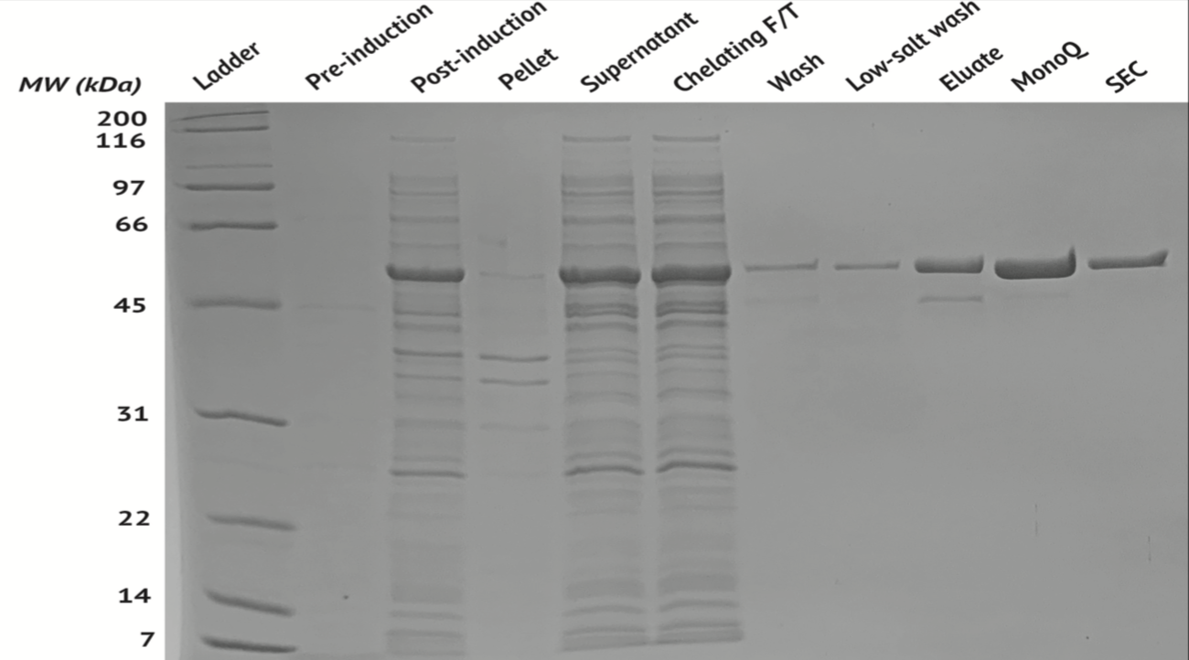

**Figure 3:** SDS-PAGE gel showing composition of samples taken at various steps of the expression and purification process. From left to right, not including ladder: pre-induction sample of culture; post-induction sample of culture, immediately after induction of expression; pellet from centrifuged lysate; supernatant from lysate; Ni-NTA chelating chromatography flow-through; Ni-NTA wash buffer flow-through; Ni-NTA low-salt wash buffer flow-through; Ni-NTA eluate; pooled fractions from MonoQ eluate, and; pooled fractions from SEC eluate, i.e. final protein selected for concentration.

Chromatograms of the MonoQ purifications are shown in **Figure 4**. Note that the fractions pooled from Nyv1 were from the sample application step, while those pooled from Vam3 had eluted off the column, i.e. Nyv1 did not bind to the column.

**Figure 4:** Left: Nyv1 MonoQ (anion-exchange) chromatogram; Right: Vam3 MonoQ (anion-exchange) chromatogram

Chromatograms of the SEC purifications are shown in **Figure 5**. Both proteins eluted cleanly. Note however the higher absorbance (A280) of Nyv1, indicating a higher concentration of protein.

**Figure 5:** Left: Nyv1 SEC (gel filtration) chromatogram; Right: Vam3 SEC (gel-filtration) chromatogram

**Discussion**

The success of both purifications lays the foundation for future investigations into the binding properties of Nyv1, Vam3, and Vps33. Before any binding assays can be conducted, however, Vps33 (the SM protein) must also be expressed and purified. This will be my immediate next step upon returning to campus in the fall.

One unusual result of my research has not escaped my notice. Contrary to expectations, Nyv1 (with an isoelectric point, or pI, of 6.01) did not bind to the MonoQ column, which had been equilibrated with a buffer containing HEPES pH 8.0 (**Figure 4**). Conversely, Vam3 behaved normally. While I cannot be sure why this occurred, I speculate that the high pI of the Nyv1 domain (SNARE motif) in its own right—about 9.67—affected its binding to the anion-exchange column, perhaps increasing the protein’s overall positive charge. This would explain why Vam3 *did* bind, as MBP-Vam3 has a pI of 5.21, and the Vam3 domain in isolation has an even lower pI, 4.28.

Going forward, I plan to investigate the binding capabilities and behaviors of these proteins using isothermal titration calorimetry. This should provide an indication of the binding energies of the proteins *in vitro*, perhaps supporting the hypothesis that they form an intermediate template for SNARE complex assembly.

**References**

1. Baker, R. W. & Hughson, F. M. Chaperoning SNARE assembly and disassembly. *Nat. Rev. Mol. Cell Biol.* **17**, 465–479 (2016).

2. Südhof, T. C. & Rothman, J. E. Membrane Fusion: Grappling with SNARE and SM Proteins. *Science* **323**, 474–477 (2009).

3. Jahn, R. & Scheller, R. H. SNAREs--engines for membrane fusion. *Nat. Rev. Mol. Cell Biol.* **7**, 631–643 (2006).

4. Sutton, R. B., Fasshauer, D., Jahn, R. & Brunger, A. T. Crystal structure of a SNARE complex involved in synaptic exocytosis at 2.4 Å resolution. *Nature* **395**, 347–353 (1998).

5. Baker, R. W. *et al.* A direct role for the Sec1-Munc18-family protein Vps33 as a template for SNARE assembly. *Science* **349**, 1111–1114 (2015).

6. Gonzalo, S., Greentree, W. K. & Linder, M. E. SNAP-25 is targeted to the plasma membrane through a novel membrane-binding domain. *J. Biol. Chem.* **274**, 21313–21318 (1999).

7. Lou, X. & Shin, Y.-K. SNARE zippering. *Biosci. Rep.* **36**, (2016).

**Acknowledgements**

With special thanks to Dr. Fred Hughson (PI) and Dr. Travis Eisemann (mentor). Thanks also to the Office of Undergraduate Research at Princeton University, without whose financial support and mentorship I would not have been able to conduct my research this summer.